**PIZZA SALES SQL QUERIES**

1. KPI’s
2. Total Revenue:

SELECT SUM(total_price) AS Total_Revenue FROM pizza_sales;

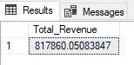

1. Average Order Value:

SELECT SUM(total_price) / COUNT(DISTINCT order_id) AS Avg_Order_Value FROM pizza_sales;

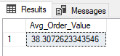

1. Total Pizzas Sold:

SELECT SUM(quantity) AS Total_Pizza_Sold FROM pizza_sales;

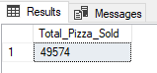

1. Total Orders:

SELECT COUNT(DISTINCT order_id) AS Total_orders FROM pizza_sales;

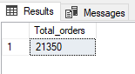

1. Average Pizzas Per Order:

SELECT CAST(CAST(SUM(quantity) AS DECIMAL(10,2)) / CAST(COUNT(DISTINCT order_id) AS DECIMAL(10,2)) AS DECIMAL (10,2)) AS Avg_Pizzas_Per_Order FROM pizza_sales;

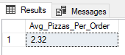

1. Daily Trend for Total Orders

SELECT DATENAME(DW,order_date) as order_day, COUNT(DISTINCT order_id) AS Total_Orders

FROM pizza_sales

GROUP BY DATENAME(DW,order_date);

***Output:***

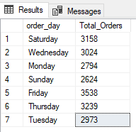

1. Monthly Trend for Orders

SELECT DATENAME(MONTH, order_date) AS Month_Name, COUNT(DISTINCT order_id) AS Total_Orders

FROM pizza_sales

GROUP BY DATENAME(MONTH, order_date);

***Output:***

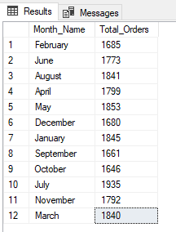

1. % of Sales by Pizza Category

SELECT pizza_category, CAST(SUM(total_price) AS DECIMAL(10,2)) as total_revenue,

CAST(SUM(total_price) * 100 / (SELECT SUM(total_price) from pizza_sales) AS DECIMAL(10,2)) AS PCT

FROM pizza_sales

GROUP BY pizza_category

***Output:***

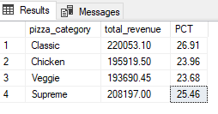

1. % of Sales by Pizza Size

SELECT pizza_size, CAST(SUM(total_price) AS DECIMAL(10,2)) AS total_revenue,

CAST(SUM(total_price) * 100 / (SELECT SUM(total_price) FROM pizza_sales) AS DECIMAL(10,2)) AS PCT

FROM pizza_sales

GROUP BY pizza_size

ORDER BY pizza_size;

***Output***

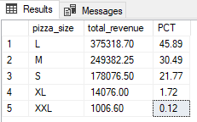

1. Total Pizzas Sold by Pizza Category

SELECT pizza_category, SUM(quantity) as Total_Quantity_Sold

FROM pizza_sales

GROUP BY pizza_category

ORDER BY Total_Quantity_Sold DESC;

***Output***

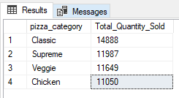

**G. Top 5 Pizzas by Revenue**

SELECT TOP 5 pizza_name, SUM(total_price) AS Total_Revenue

FROM pizza_sales

GROUP BY pizza_name

ORDER BY Total_Revenue DESC;

***Output***

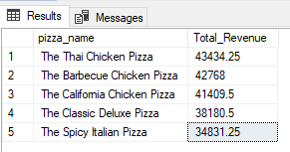

**H. Bottom 5 Pizzas by Revenue**

SELECT TOP 5 pizza_name, SUM(total_price) AS Total_Revenue

FROM pizza_sales

GROUP BY pizza_name

ORDER BY Total_Revenue;

***Output***

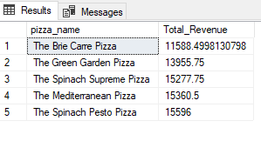

**I. Top 5 Pizzas by Quantity**

SELECT TOP 5 pizza_name, SUM(quantity) AS Total_Quantity

FROM pizza_sales

GROUP BY pizza_name

ORDER BY Total_Quantity DESC;

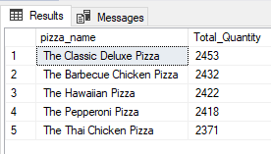

1. **Bottom 5 Pizzas by Quantity**

SELECT TOP 5 pizza_name, SUM(quantity) AS Total_Quantity

FROM pizza_sales

GROUP BY pizza_name

ORDER BY Total_Quantity ASC;

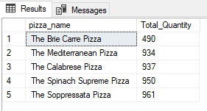

1. **Top 5 Pizzas by Total Orders**

SELECT TOP 5 pizza_name, COUNT(DISTINCT order_id) AS Total_Orders

FROM pizza_sales

GROUP BY pizza_name

ORDER BY Total_Orders DESC;

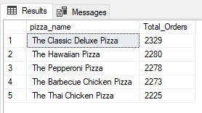

1. **Bottom 5 Pizzas by Total Orders**

SELECT TOP 5 pizza_name, COUNT(DISTINCT order_id) AS Total_Orders

FROM pizza_sales

GROUP BY pizza_name

ORDER BY Total_Orders ASC;

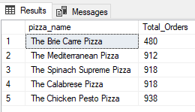

***NOTE***

If you want to apply the pizza_category or pizza_size filters to the above queries you can use WHERE clause. Follow some of below examples

SELECT Top 5 pizza_name, COUNT(DISTINCT order_id) AS Total_Orders

FROM pizza_sales

WHERE pizza_category = 'Classic'

GROUP BY pizza_name

ORDER BY Total_Orders ASC